What happens when I click, what!

Dashboard:

Red Yellow Gem up left corner:
- Opens the shop

Avatar in the middle
- Shows a little cogwheel to open “change avatar” Menu, allows player to change portrait, name, race and role
- Arrows right and left will switch to next avatar (Future feature, let's stick with one avatar for now)

PLAY button right bottom
- Initiates the storyline core feature with the chosen avatar

MENU button bottom left
- Toggles the side-navigation-menu

Side-Navigation-Menu:

- Friends Button - opens the Friends Menu (shows friends online/offline status and avatar)
  - Add friend opens the add friend screen (referral-system, friend textfield, friend requests)
    - Referral link button opens the referral link copy popup with copy button
      - button copies the referral deep link (firebase) to clipboard.
    - Add friend button bottom right opens the add friend popup
      - Friend textfield and green plus to add friends
    - Friendlist button to navigate back to friendlist
  - Remove friend opens the remove friend screen
    - List of friends with remove button

- Achievements-Button opens the achievement-screen showing the list of achievements
  - Collection Button to check the collection (?) the collection shows all items purchased for gems, so frames, portraits and story-expansions
  - Shop button to open shop

- Settings-Button opens the Settings (sound, sfx, notifications,
account-settings, help)
- Account opens the account settings
  - PlayerNameChange / cost 30 gems, player can insert new name.
  - emailChange for free
  - ManageSubscription if subscription is active
  - SubscribeButton
    - Show Subscription Benefits Guardian and Patron
- Help button opens the help page on the website

- Credits-Button opens the Credits
  - With our Names and role
  - Donate Button
    - to let the player choose how many gems they want to donate (10,20,50,all - shows the amount of gems the player has in total)
  - Credits Button to navigate back from the DonateScreen

- GEM-Button opens the SHOP! (Frames, Portraits, Expansions, BuyGems, Collection)
  - Frames Button
    - show the frames changing room
  - Portrait Button
    - show the portraits changing room
  - Expansions Button
    - show the story-expansions products in scrollable list
  - BuyGemsButton
    - shows the gem-products

- News-Button opens the News! (Notifications and Blog for patchlogs and sales) shows notifications first
  - News button
    - show the blog eg patchlogs
  - “Read More” Button
    - link to website

- HOME-Button to navigate to the DASHBOARD!

Storyline feature starts by pressing Play in the dashboard - loads in the first random(all) encounter(image,text,solutions,type?)
- Get encounter from database
  - Load image
  - Load text
- Get solutions for this encounter
  - Check if solutions are in avatar inventory
global cooldown 6 seconds(solutions locked for 6 seconds)
- Bag
  - Shows an overlay(inventoryBG) over the encounter picture, listing all items (weapons, tools, treasure) the avatar has in the inventory
- Spellbook
  - Shows and overlay(inventoryBG) over the encounter picture, listing all Spells the avatar has in the inventory

- Solution Dice middle of - (two seconds animation) (hides the encounter text)
  - Rolls a D20(random number 1-20) (always possible)
    - 1 = adds random(all) itemtype:any x2 to avatar inventory;
      - Moves the dice to the left, beside it shows “Prosperity!” in textfield, while on the right side showing the reward(s) and a “accept” button -
        - When accepted --2 secanimation- all the buttons and even the encounter imagine shrink behind the reward, the treward then moves in a curve to the bag or skillbook
          - Reveals the next encounter

    - 2-3 = adds random(all) itemtype:any x 1 to avatar inventory;
      - Moves the dice to the left, beside it shows “Fortune!” in textfield, while on the right side showing the reward(s) and a “accept” button -
        - When accepted --2 secanimation- all the buttons and even the encounter imagine shrink behind the reward, the treward then moves in a curve to the bag or skillbook
          - Reveals the next encounter

    - 4-10 just moves to next random encounter;
      - Moves the dice to the left, beside it shows “Disengage!” in textfield, while on the right side showing the “accept” button -
        - When accepted --2 secanimation- all the buttons and even the encounter imagine shrink into the middle and disappear
          - Reveals the next encounter

    - 10-18 = removes one random(all) itemtype:treasure from avatar- inventory;
      - Moves the dice to the left, beside it shows “Hardeship!” in textfield, while on the right side showing the removed items and the “accept” button -
        - When accepted --2 secanimation- all the buttons and even the encounter imagine shrink into the middle and disappear
          - Reveals the next encounter

    - 19-20 = removes random(all) itemtype:treasure x2 from avatar-inventory
      - Moves the dice to the left, beside it shows “Misery!” in textfield, while on the right side showing the removed items and the “accept” button -
        - When accepted --2 secanimation- all the buttons and even the encounter imagine shrink into the middle and disappear
          - Reveals the next encounter

- Solution B (left of dice) if the Item is in the avatar inventory = usable(shows 100% opacity); otherwise unusable (50% opacity)
  - When used,
    - Adds a use(SolutionUsed) to the AvatarSolutionsEntry of the item (AvatarSolutions),
    - adds a random(all) item or to the inventory
      - Moves the dice to the left, beside it shows “Success!” in textfield, while on the right side showing thereward and the “accept” button -
      - When accepted -2 sec animation- all the buttons and even the encounter imagine shrink behind the reward, the reward then moves in a curve to the bag
        - Reveals the next encounter

- Solution C - Skill (right of dice) if the Skill is in the avatar inventory and off cooldown = usable(shows 100% opacity); otherwise unusable (50% opacity)
  - When used, if type skill type 1 (buy Item)
    - adds an item to avatar-inventory (default random(all), or type specified by entry in solution - random weapon, random tool, random treasure)
    - Removes a random treasure from avatar-inventory
    - Shows the “Success” overlay, showing the random item and an “accept” button - when used
      - Moves to the next encounter (two seconds animation)
  - When used, if skill type 2 (buy skill)
    - adds a random(all) skill to avatar-inventory
    - Removes a random treasure from avatar-inventory
    - When accepted -2 sec animation- all the buttons and even the encounter imagine shrink behind the reward, the reward then moves in a curve to the bag
      - Reveals the next encounter

  - When used, if skill type 3 (use Skill)
    - Sets a cooldown of 7 encounters for the skill (usable again on 8th encounter)
    - adds a random(all) itemtype:any to avatar-inventory
    - When accepted -2 sec animation- all the buttons and even the encounter imagine shrink behind the reward, the reward then moves in a curve to the bag
      - Reveals the next encounter

- 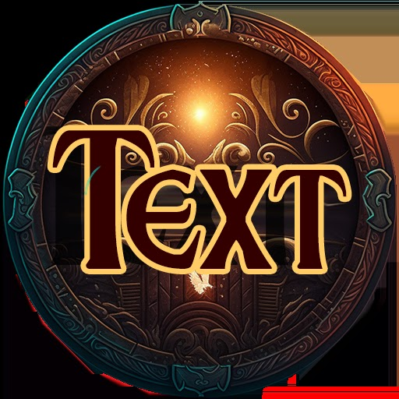Textbutton top right corner of encounter-image
  - Toggles an overlay(inventoryBG) with the scrollable encounter text on top of the encounter image

- Menu (bottom left as always)
  - Toggles the NavigationMenu

- 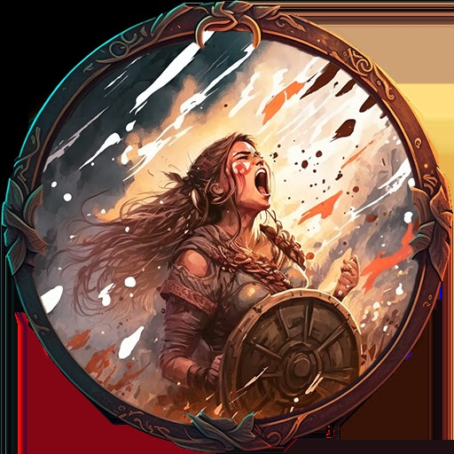Gethelp (bottom middle)
  - Get all currently playing solo online players (favorised friends)
      - Choose 10 friends random:all (fill with other players if not 10 friends available)
        - Send notification “303” - allows random players to join the session / rush to help

